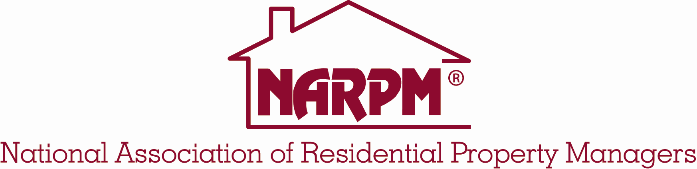

What Do You Receive From Your NARPM® Membership?

- Business Building Referrals and Marketing Support – Build your business with referrals through networking with other members across the country and through the NARPM® website and Annual Membership Directory.

- National Website – A free listing on the NARPM® website at www.narpm.org gives you international exposure.

- Code of Ethics and Standards of Professionalism – NARPM® members are committed to the highest level of professionalism and ethics, giving them a powerful marketing advantage with prospective clients.

- Unparalleled Networking Opportunities – Membership in NARPM® opens up networking opportunities with property management colleagues throughout North America and around the world.

- Industry Specific Educational Opportunities – Education is a focal point of the association. Through its Annual Convention and Trade Show, Leadership Training sessions, state conferences, and locally sponsored education courses, NARPM® provides property management courses, seminars and roundtable workshops. NARPM® education promotes an exchange of ideas among members and offers fundamental as well as advanced training in many facets of property management. NARPM® offers one and two-day courses cover topics such as marketing, operations, maintenance, tenancy, risk management, technology and personnel practices. Coursework is required of members who wish to earn NARPM® designations.

- NARPM® Offers Free Webinars monthly - As a NARPM® member, you can participate for FREE in any scheduled Webinar. The schedule of webinars in updated at www.narpm.org/about/echapters.

- Nationally Recognized Professional Designation Program – NARPM® has developed a certification program that enables the property management professional to continually update and refine crucial skills. Achieving skills and overall competence in a changing market. There are four such designations: RMP® – Residential Management Professional, MPM® – Master Property Manager, CRMC® – Certified Property Management Company, and CSS^{sm} – Certified Support Specialist.

- Annual Convention & Trade Show and Leadership Training – The Annual Convention and Trade Show is filled with opportunities for learning, networking and examining the latest technology for property management. The Leadership Training sessions offer members the opportunity to learn about NARPM® leadership and learn new techniques to motivate, inspire, lead and succeed.

- Regional Conferences – Spring NARPM® holds regional conferences throughout the country. Personal, professional and company growth are the direct results of NARPM® at the grassroots level of our chapters. It’s where the core energy of NARPM® resides, and the conferences organized by the local chapters are key to many of the National Association’s accomplishments. To find latest schedule go to Personal, professional and company growth are the direct results of NARPM® at the grassroots level of our chapters. It’s where the core energy of NARPM® resides, and the conferences organized by the local chapters are key to many of the National Association’s accomplishments.ttp://www.narpm.org/conferences/index.htm .

- Broker/Owner Retreat – Brokers and owners of residential property management companies come together annually for the NARPM® Broker/Owner Retreat. For details on this exciting event go to http://www.narpm.org/conferences/brokerowner/

- Current Industry-Related News and Information – Regular publications keep you current on issues of interest and concern to residential property managers. The NARPM® monthly news magazine, the Residential Resource, is the source for industry information, legislative updates, association news and tips for making your business more successful and effective.

- Awards Programs – Prestigious awards are presented each year to NARPM® members and chapters who distinguish themselves with outstanding achievements.

- Leadership Opportunities – Participation in national committees and local chapters is an excellent way to build your individual leadership skills−skills that are transferable to your professional career. You can participate in shaping the residential property management industry by joining a NARPM® committee, serving as a local chapter leader or serving as a national director.

- NARPM® Logo – As a NARPM® member you are entitled to use the NARPM® logo. This logo is most often used by our members on company letterhead, in advertising, on business cards, etc. Guidelines for using the NARPM® logo are available online at www.narpm.org.

- Publications – In addition to the monthly Residential Resource, NARPM® has available to members a various supply of publications giving ideas and possible enhancements to lease forms, office management, website, etc. To find out what is available, contact NARPM® National.

