Automatic Debit Authorization Form
Griswold Real Estate Management, Inc.

The information that you provide on this form will allow Griswold Real Estate Management, Inc., to directly debit your bank account for your monthly rent. This form must be filled out completely and legibly, and be delivered to our office before the twentieth (20th) of the month to ensure enough time to guarantee processing for the next calendar month.

TENANT INFORMATION | ____________________________  Tenant  ____________________________  Property Address Unit #  ____________________________  City, State, Zip  ____________________________  Home Phone #  ____________________________  Cellular # | ____________________________  Name of Individual or Entity’s account to be debited (Bank Account Holder)  ____________________________  Address of record (if different from the property address)  ____________________________  City, State, Zip (if different from the property address)  ____________________________  Work Phone #  ____________________________  Email Address
DEBIT ACCOUNT INFORMATION | Checking Savings  ____________________________  Name of Financial Institution  ____________________________  Financial Institution Address  ____________________________  City, State, Zip  ____________________________  Routing & Transit Number (9-digit number)  ____________________________  Account Number | 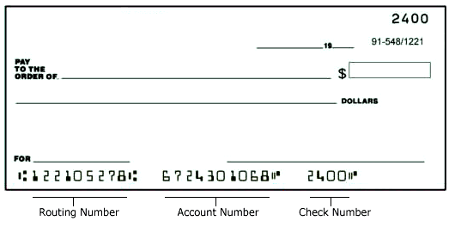

Terms and Conditions / Authorization Agreement

Debit transactions are scheduled for the first (1st) of the month. These transactions will post between the first (1st) and fifth (5th) of every month, depending on weekends and bank holidays. The automated debit will be for the current monthly rent only. Any additional fees incurred on the account such as late charges or damages must be paid by check, sent to Griswold Real Estate Management, Inc. Should your rent change, your account will be debited for the new amount automatically. The account owner is responsible for verifying routing and account information with their bank before submitting authorization.

This authorization will begin upon written confirmation delivered via U.S. Mail. This authorization is to remain in full force and effect until Griswold Real Estate Management, Inc., has received written notification from the renter of the property, or the Debit Account Owner, should the two be different. This written notification should be received thirty (30) days prior to the last transaction date, as to ensure that the automatic debit process has been stopped.

Upon cancellation of the authorization, you will be notified via U.S. Mail. This confirmation will be sent upon cancellation by any party within the authorization. Griswold Real Estate Management, Inc., reserves the right to cancel this authorization at any time.

Should an NSF notification be received from your bank, you will automatically be cancelled from the automated debit authorization, a twenty-five ($25) dollar NSF charge will be added to your account, and you will be notified via U.S. Mail. Additionally, you will be responsible for any late fees that may accrue on your account during the NSF process. You will be required to pay your balance with a cashier’s check and you will not be granted automated debit authorization for six (6) months.

I/We acknowledge our understanding of the above terms, and authorize monies to be debited from the account listed above by Griswold Real Estate Management, Inc., and ABC Bank and Trust.

_____________________________________________________________________________________________________________________________________
Tenant Signature Printed Name Date

_____________________________________________________________________________________________________________________________________
Additional Tenant Signature Printed Name Date

_____________________________________________________________________________________________________________________________________
Account Owner Signature Printed Name Date
(If different from Renter)

Please attach a voided check to this form and return to: Griswold Real Estate Management, Inc.
123 Main Street, Suite 100, San Diego California 92101

